Final Proposal

Project members: Lauren Calso, David Colonia, David Cruz, Phillip Sohn

Title: Wrong Side of the Tracks

Topic: Give context surrounding the culture of graffiti. How it has affected the culture of the Bay Area and evolved into a legitimate art form.

Rationale: This project has a lot of anthropology behind it. The data here is largely qualitative and the goal of the project is to communicate a non-technical research assignment into a technical framework. This is done by combining web scraping and visualization with data analysis (SK Learn) to provide a ethnographic representation of the graffiti culture.

Problem: Using the metric of juvenile crime figures, we can see that the crime number for Santa Clara County is significantly higher than Alameda County (2008-2012). Can these figures be attributed to graffiti?

Data Set:

<https://openjustice.doj.ca.gov/crime-statistics/arrests>

https://data.oaklandnet.com/Public-Safety/CrimeWatch-Maps-Past-90-Days/ym6k-rx7a/data

Screenshots of relevant visualizations:

Visualizations include:

* SK Learn
* Python Pandas
* Beautiful soup
* HTML/CSS/Bootstrap
* Tableau

Sketch of final design:

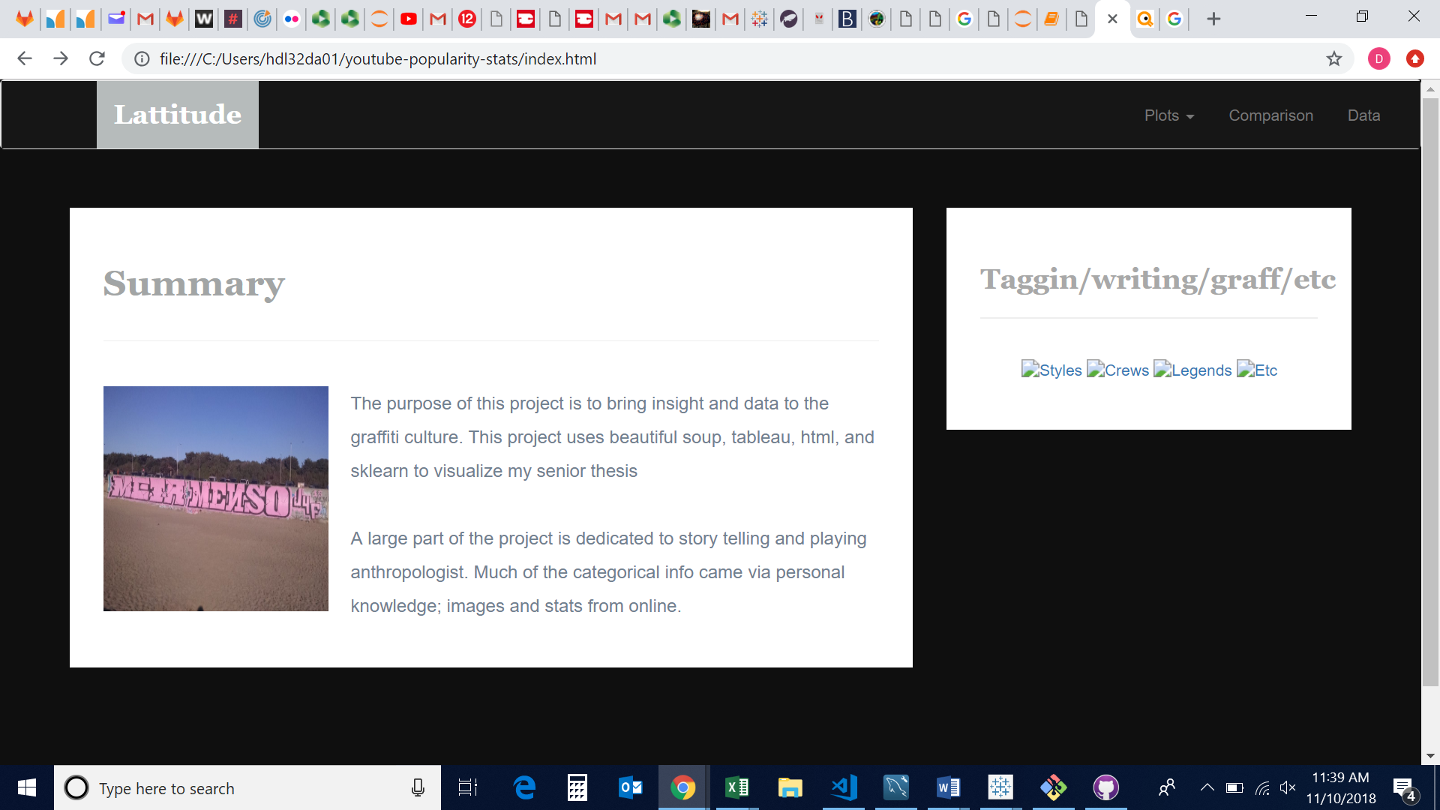

GitHub Final Project Repository: https://github.com/LCalso/Final-Project